GUEST OF THE MONTH/June 2026
Anselmo Collins, Sr Assistant General Manager & Chief Operating Officer
Los Angeles Department of Water & Power

UPDATE ON WATER ISSUES

Summary by Robert Yoshimura

This month’s guest speaker, Anselmo Collins, gave a brief overview of four key issues affecting the Los Angeles water supply system:

- Challenges facing Los Angeles’s Mono Basin water supply
- The Tillman Water Reclamation Project
- Pure Water LA
- Automated Metering Infrastructure (AMI)

The Mono Lake Committee is a long-established conservation group focused on protecting Mono Lake. It has negotiated agreements with DWP and secured State Water Resources Control Board (SWRCB) rulings that limit exports from the Mono Basin for domestic use in Los Angeles. Most significant is SWRCB Decision 1631, issued in 1994, which cut the amount of water available for export to Los Angeles from more than 100,000 acre-feet per year to less than 16,000. The decision’s purpose is to raise Mono Lake to a sustainable elevation of 6,392 feet above sea level.

Reaching that sustainable level has been difficult, largely because climate change–related drought has affected the eastern Sierra since 2000. Although DWP has fully complied with Decision 1631, the Mono Lake Committee is now seeking legal changes that would reduce Los Angeles’s exports from the Mono Basin to zero. Recent studies show that the difference in time needed to reach the target lake level under the current export plan (26 years) versus a zero-export scenario (22 years) is only four years. In that context, the tradeoff between minimal ecological benefits to Mono Lake and the costs of replacement water and the renewable energy generated by that water does not appear reasonable.
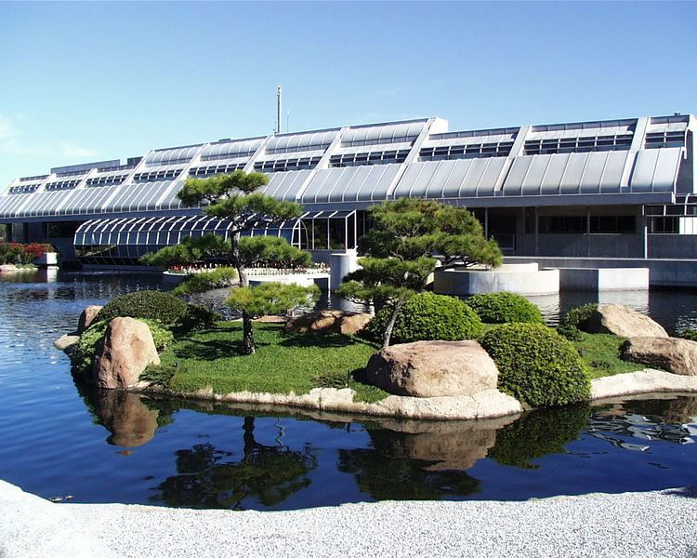

The Tillman Water Reclamation Project (WRP) is currently the largest water reuse project under construction in California and will produce at least 25 million gallons per day (MGD) (approximately 28,000 AF/yr). Since the project started, opportunities to expand the capacity to 45 MGD (49,500 AF/yr.) have been found and will be implemented. The added capacity will require additional infrastructure outside the plant such as upgrades to Balboa Pumping station, a new interceptor sewer to divert sewage that would otherwise be transported to Hyperion, and a means to deliver finished water northward to the perimeter of the San Fernando Valley. The possibility of diverting water from the Los Angeles River is also under consideration, however permitting and coordination issues will first have to be resolved.
Tillman Water Reclamation Plant

The project cost estimate is $1 billion, of which approximately half has been secured, much of it from outside sources (grants and loans). Construction is 30% complete and progress has been exceptional because of a 24/7 work schedule made possible by the isolated location of the jobsite. The project will include a learning center where the extensive treatment process will be explained emphasizing the safety of the finished water for drinking water purposes.

The initial plan for use of the effluent from Tillman WRP is to put it into the San Fernando Groundwater Basin for extraction at existing and future well fields. Effluent will be pumped to both the Hansen and Tujunga spreading grounds for infiltration underground. During and after major storm events when the Los Angeles County Flood Control District has priority use of the Hansen spreading basins, DWP is planning to construct injection wells to always enable continued delivery of effluent to the groundwater basin.

Groundwater extraction capacity will expand significantly in the near term. The wellhead treatment plant at North Hollywood West has been completed, and the North Hollywood and Tujunga plants are scheduled for completion this year. Once all three plants are finished, total extraction capacity will reach 300 cubic feet per second (cfs), approximately equal to 217,200 AF/yr. Additional facilities are planned to move groundwater west to the future Roscoe Trunkline and north to the upper perimeter, allowing San Fernando groundwater to be used within the San Fernando Valley, which is not currently possible. These facilities will also eliminate MWD’s “blind spot,” a gap in its pipeline system that prevents water from reaching parts of the west valley when the California Aqueduct is out of service.

A final option is to send Tillman WRP effluent to the Los Angeles Aqueduct Filtration Plant (LAAFP) to supplement raw water supplies. This would not qualify as direct potable reuse as long as reclaimed water makes up less than 10% of the plant’s total inflow. From there, the water could be distributed to nearly any part of the city.
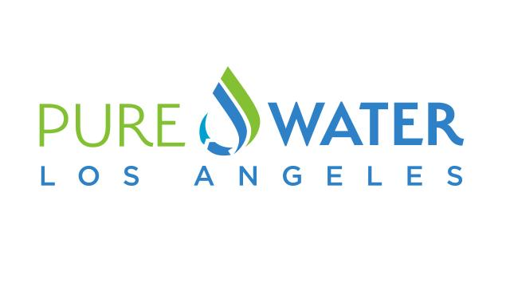
Pure Water LA is an ambitious $26 billion project to recycle up to 230 MGD (approximately 257,000 AF/yr) of reclaimed water from Los Angeles’ Hyperion Water Reclamation Plant for domestic uses in Los Angeles. Effluent from Hyperion WRP will be used for both indirect potable reuse (IPR) by putting it into the Central and West Basins, and to the San Fernando Basin for groundwater recharge, and direct potable reuse (DPR) by pumping it to the LAAFP where it will constitute more than 10% of the plant’s influent.

IPR in the Central and West Basins will require extensive study to characterize the water quality of those basins to determine the level of treatment that will be required when it is extracted. DWP is considering a partnership with the Water Replenishment District (WRD) and West Basin Municipal Water District to assist with that characterization. West Basin MWD is currently using Hyperion effluent at its Edward Little WRP for IPR via groundwater injection wells.

The goal of the project is to use most of the water for DPR at the filtration plant. However, the mandated sequence of treatment processes needed to qualify for DPR requires ozonation and biological activated carbon (BAC) treatment to occur as the first steps, followed by filtration, reverse osmosis (RO), and advanced oxidation/ultraviolet irradiation (AOP/UV). Ozonation and BAC are not required for IPR because infiltration or injection into a groundwater basin provides the natural attenuation of contaminants that replace Ozone/BAC. The mandated treatment sequence means that every drop of water produced by the plant will unnecessarily meet DPR standards. In order to save money, DWP will propose to rearrange the treatment sequence to put Ozone/BAC at the end such that water intended for IPR can easily bypass those processes.
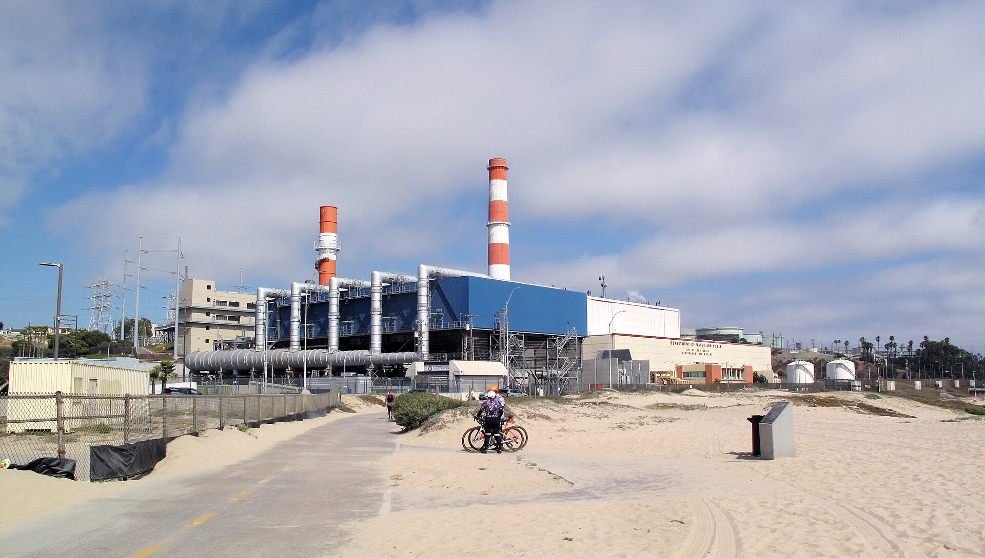
Hyperion Water Reclamation Plant
DWP is planning to perform extensive pilot studies using different sequences of treatment processes to prove that its proposal will provide the same efficacy of treatment as the sequence mandated by the state.

Transporting the water to the LAAFP will require the construction of a 30-mile pipeline and three pumping stations along with much tunneling due to the alignment through a densely developed urban area. Such construction comes at high cost, thus optimizing the use of Tillman WRP to produce as much of the reclaimed water as possible will be needed to fine-tune the project.

Automated Metering Infrastructure (AMI) in the Water System is still under study due to complicating factors. The Power System is moving ahead with AMI because power is available at all their meters. The Water System is concerned about battery life which the meter industry claims exceed 20 years. No water utility has had automated meters for 20 years and those who have implemented them are reporting a shorter lifetime. Most automated meters incorporate operating and customer convenience features that tend to shorten battery life depending on their frequency of use.

At Southern Nevada Water Authority, who recently implemented AMI, they experienced not only short battery life, but multiple batteries that died at the same time. The sudden death of multiple batteries forced the agency to estimate bills while dead batteries were being replaced. The estimated bills resulted in multiple lawsuits. Other water utilities have reported battery lifetimes of 11 years, significantly less than the expected 20 years. Another utility reported having to replace 15% of the meters each year which is triple the replacement rate that DWP has historically experienced. Before launching AMI, DWP is initiating a 6-year pilot study to assess different manufacturers and modes of use to assure that it has the facts it needs to make a responsible decision.

